**Interview Questions and Answers**

Q:**What is AMDP?**

A: Allows developers to create and execute database procedures in an ABAP environment using ABAP method.

AMDP is the top-down approach of using HANA Database Procedures in ABAP.  Allow the execution of complex calculations inside the HANA database. AMDP only requires ABAP Application Server (AS) for developing, managing and calling database procedures.

Q: **What makes AMDP class and ABAP method different from normal class and method?**

A:

**AMDP class**

* Can contain both regular methods and AMDP methods.
* One or more AMDP methods can be present in AMDP class.
* Can only be created using ADT.
* class with AMDPs must implement interface IF_AMDP_MARKER_HDB

**AMDP Methods**

* AMDP methods can be defined in the public, protected, or private visibility section of the class.
* Although you can define AMDP methods as instance methods, they are always executed like static methods.
* All AMDP method parameters have to be passed by value, and must be of either table or scalar types. Pass by reference is not permitted
* Exporting, importing and changing parameters are allowed. Returning parameters are not allowed
* AMDP Method is specified with addition BY DATABASE PROCEDURE in the method implementation part, followed by the database system (for example, HDB) and the implementation language (for example, SQLScript).
* For parameters of table types, the line types have to consist of elementary components, because nested tables are not supported. ABAP Dictionary structure types are not allowed.

Q:**Comparision between ABAP CDS view and AMDP**

A:

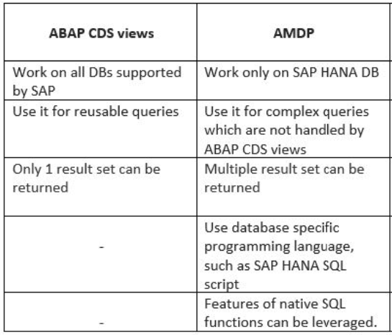

Q:**When to use ABAP SQL, CDS views, AMDP ?**

A: ABAP SQL, CDS views, and AMDP (ABAP Managed Database Procedures) are all options for accessing data in SAP systems. The choice of which to use depends on various factors such as performance, complexity, and data structure.

**ABAP SQL** should be used when simple data retrieval or manipulation is required, and the underlying database tables or views are well-structured. ABAP SQL can be used for basic SELECT, INSERT, UPDATE, and DELETE statements, and it is suitable for simple queries that do not require complex data processing.

**CDS views**should be used when a more complex view of data is required, and when the data needs to be accessed from multiple sources. CDS views can be used to define complex joins, unions, and aggregations, and they are optimized for performance. They are also suitable for creating reports and analytical applications.

**AMDP** should be used in situations where complex database processing is required, and performance is a concern. For example, if you need to perform complex calculations, aggregations, or join operations on large data sets, using AMDP may be a good option.

It allows database-specific functions to be accessed that do not exist in Open SQL.

AMDP allows developers to write database procedures in ABAP that can be executed on the database server, rather than in the application server, which can result in improved performance.

In summary, ABAP SQL, CDS views, and AMDP all have their use cases, and the choice of which to use depends on the specific requirements of the task at hand.